DIY Halloween Decorations
(Right-click on images and select Open Hyperlink for instructions)

- House & Garden Decos -

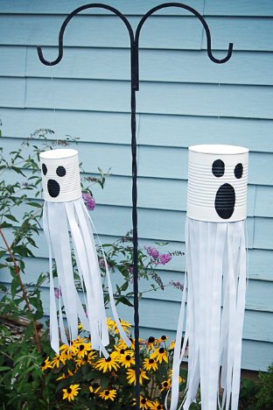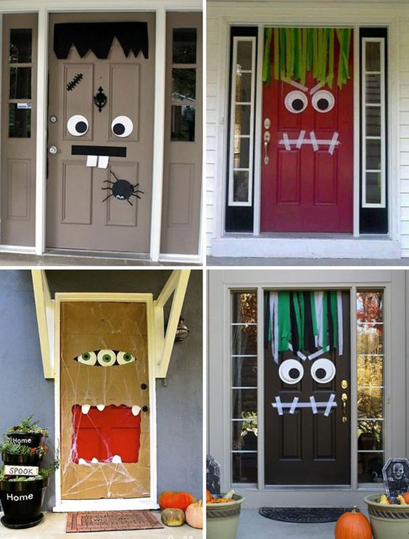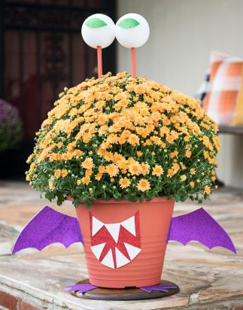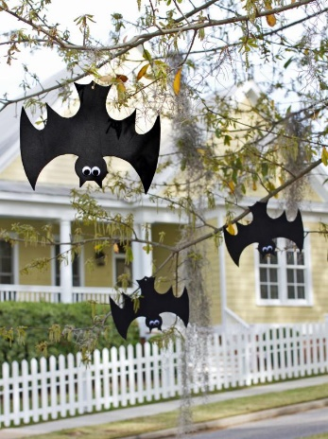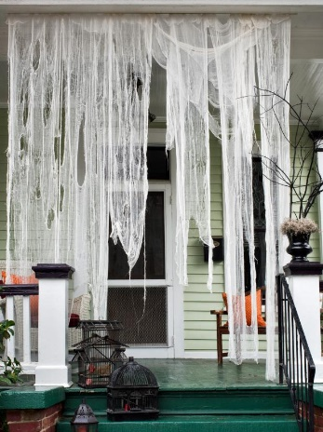
Tin Can Garden Ghost Monster Door Decoration Blooming Beast Flower Pot Hanging Foam Bats Ghostly Draperies
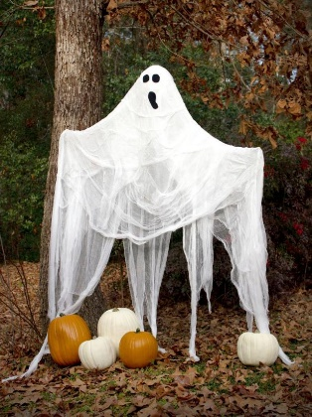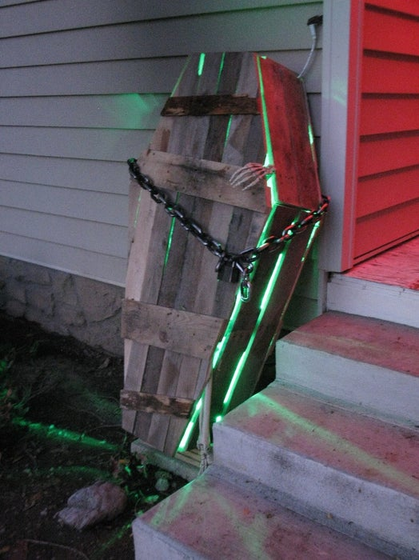
Life-sized Garden Ghost Foam Gravestones Cardboard Tombstones Spooky Window Silhouettes Light Up Zombie Coffin
DIY Halloween Costumers & Make-up
(Right-click on images and select Open Hyperlink for instructions)
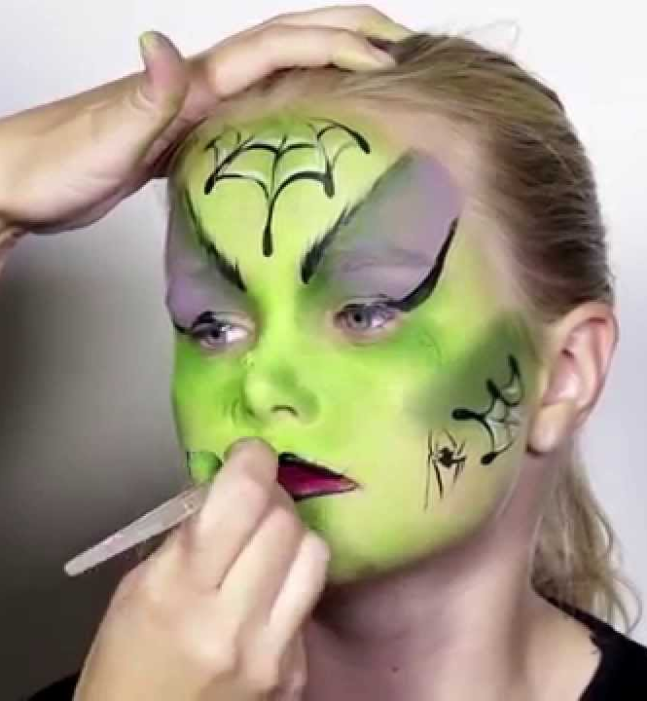
Halloween Makeup Ideas Halloween Makeup Tutorials Easy Kids Makeup Tutorials Easy Zombie Makeup Tutorial
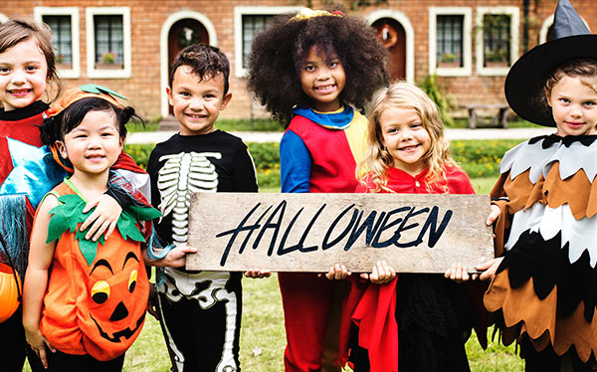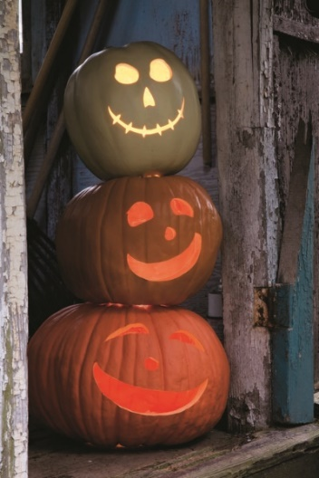
DIY Halloween Costumes DIY Halloween Costume Ideas for Kids & Adults Jack-O-Lantern Ideas

