DIY Halloween Decorations
(Right-click on images and select Open Hyperlink for instructions)

- House & Garden Decos -

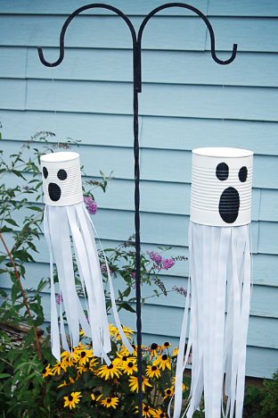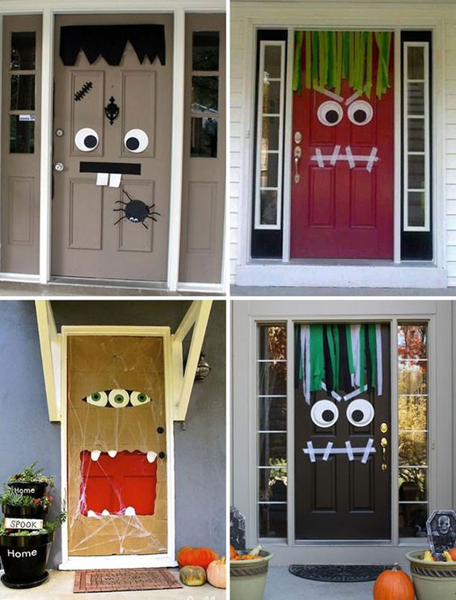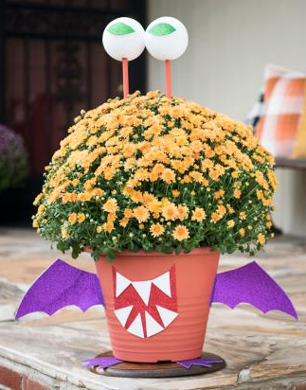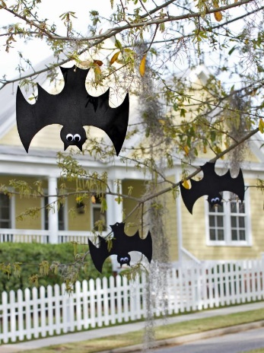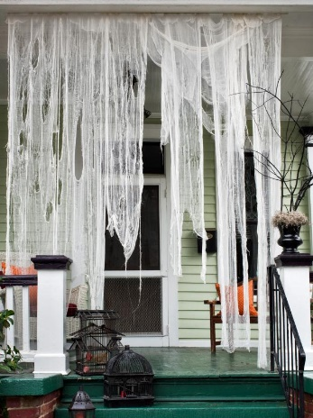
Tin Can Garden Ghost Monster Door Decoration Blooming Beast Flower Pot Hanging Foam Bats Ghostly Draperies
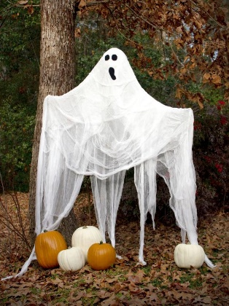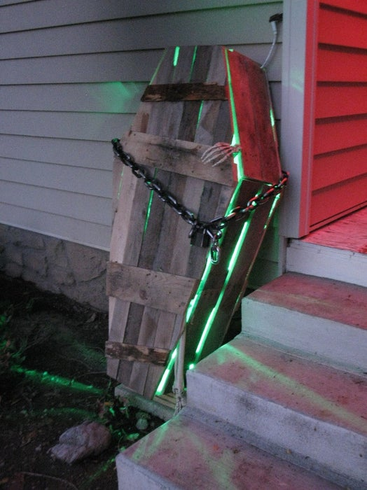
Life-sized Garden Ghost Foam Gravestones Cardboard Tombstones Spooky Window Silhouettes Light Up Zombie Coffin

